Manual for Setting Up Soundmodem

- Before starting: you will need the usb hub for the remote client (ALIX without internet connection). Because it will require three USB connections; one for usb-audio, one for controlling the PTT with usb-serial and one for connecting to the sink mote with another usb-serial.
- Connect to the machine via serial terminal.
- Type in `remountrw` to remount the file system as writable.
- Connect one side of the ethernet cable to eth1 (middle port), and the other side to your computer.
- Type in `ifconfig eth1 192.168.1.1 up`.
- Open a terminal in your computer and type in `sudo ifconfig eth0 192.168.1.2 up`.
- Open an ssh connection to the Alix machine by typing `ssh root@192.168.1.1`
- The password should be `hades12`. If it’s not, then it is `voyage`.
- Plug in the usb audio.
- Check that it is connected from dmesg.
- Type in `aplay –l` to the terminal and see that it is actually connected. A list of audio devices should show up, and there should be only one device with a card number. Let’s say this card number is X for now.
Example output from my computer:
**** List of PLAYBACK Hardware Devices ****
card 0: Intel [HDA Intel], device 0: STAC92xx Analog [STAC92xx Analog]
Subdevices: 1/1
Subdevice #0: subdevice #0
card 0: Intel [HDA Intel], device 1: STAC92xx Digital [STAC92xx Digital]
Subdevices: 1/1
Subdevice #0: subdevice #0

- Type in `alsamixer --card X` to open alsa sound settings. Set the speaker output to 100% and the mic output setting to 0%. Press TAB, now the setting for mic input should show up. Set it to 25% or 6dB.
- Plug in the usb serial (FTDI cable). Check that it is connected from dmesg, also keep the device name in your mind. Let’s say it is `/dev/ttyUSBX` for now.
- Type in `chmod 666 /dev/ttyUSBX` to set the permissions correct (this is just to be safe).
- Now we have to set the settings for soundmodem. Type in `nano /etc/ax25/soundmodem.conf`. It’s an xml file containing the settings.
Example soundmodem.conf file:
<?xml version="1.0"?>
<modem>
<configuration name="alp">
<channel name="Channel 0">
<mod mode="afsk" bps="1200" f0="1200" f1="2200" diffenc="1" inlv="8" fec="3" tunelen="32" synclen="32" filter\
="hamming"/>
<demod mode="afsk" bps="1200" f0="1200" f1="2200" diffdec="1" inlv="8" fec="3" mintune="16" minsync="16" filt\
er="hamming"/>
<pkt mode="MKISS" ifname="sm6" hwaddr="SA0BXI-6" ip="10.0.0.6" netmask="255.255.255.0" broadcast="10.0.0.255"\
file="/dev/soundmodem0" unlink="1"/>
</channel>
<chaccess txdelay="400" slottime="200" ppersist="40" fulldup="0" txtail="10"/>
<audio type="alsa" device="plughw:1,0" halfdup="1" capturechannelmode="Mono"/>
<ptt file="/dev/ttyUSB0" gpio="0"/>
</configuration>
</modem>

- The `<mod>` and `<demod>` tags should be the same as example. You shouldn’t modify them.
- The `<pkt>` tag’s mode should be `MKISS` as in the example. `ifname` is the interface name. This name will be the name in ifconfig. `hwaddr` should be a unique callsign. `ip` should be a unique IP address in the network you want to set. `netmask` should stay the same as in the example. And finally the `broadcast` should be set according to the `ip`. The rest of the settings need not to be touched.
- The `<chaccess>` tag is also very important. If you are going to use YAESU radios the `txdelay should be 150 and `slottime` should be 100. But if you are going to use the MAAS handhelds the `txdelay` should be 400 and `slottime` should be 200. The rest of the settings need not to be touched.
- The `<audio>` tag should be set according to the usb audio. `type` is always `alsa`. `device` is set according to the card number(which was X). So the `device` should be `plughw:X,0`. The rest of the settings need not to be touched.
- Finally `<ptt>` tag should be set according the usb serial (FTDI cable). The `file` setting should be set to the `/dev/ttyUSBX`. The rest of the settings need not to be touched.
- Now we are going to set the settings for axports file. This file is used by applications which DOESN’T use IP layer on top of AX.25 (e.g. aprx, xastir).
- Type in `nano /etc/ax25/axports`. This is a very simple file with only one line with it.
Example axports file:
# /etc/ax25/axports
#
# The format of this file is:
#
# name callsign speed paclen window description
axport6 SA0BXI-6 1200 255 7 144.8 MHz APRS (1200 bps)

- The `name` should be something that you define it will be required by applications like aprx or xastir. The `callsign` MUST be the same callsign that you entered in the `soundmodem.conf`. The speed, paclen, window and description need not to be changed.
- Now you are ready to start the soundmodem. You can start soundmodem by typing `soundmodem &`. After that check that your interface has showed up in ifconfig by typing `ifconfig`.
- Optional: If you plug in a speaker or an earphone to the speaker output(green) of the usb audio and try to ping an IP address in the soundmodem’s subnet, you should hear the ping from the speaker.
- Repeat steps 1 to 25 to set up the other Alix machine, but with different `hwaddr`(callsign) and `ip`(IP address).
- For handhelds the cable connections should be as below picture. The red connector is `Audio Out From Alix To Audio In of Radio`. The green connector is `Audio In To Alix From Audio Out of Radio`. The yellow connector is the ground connection. The white connector is the Push-to-Talk connection.
- The usb serial (FTDI cable) should be connected to the 6-pin connector with the black stripe. The black stripe represents the ground line.
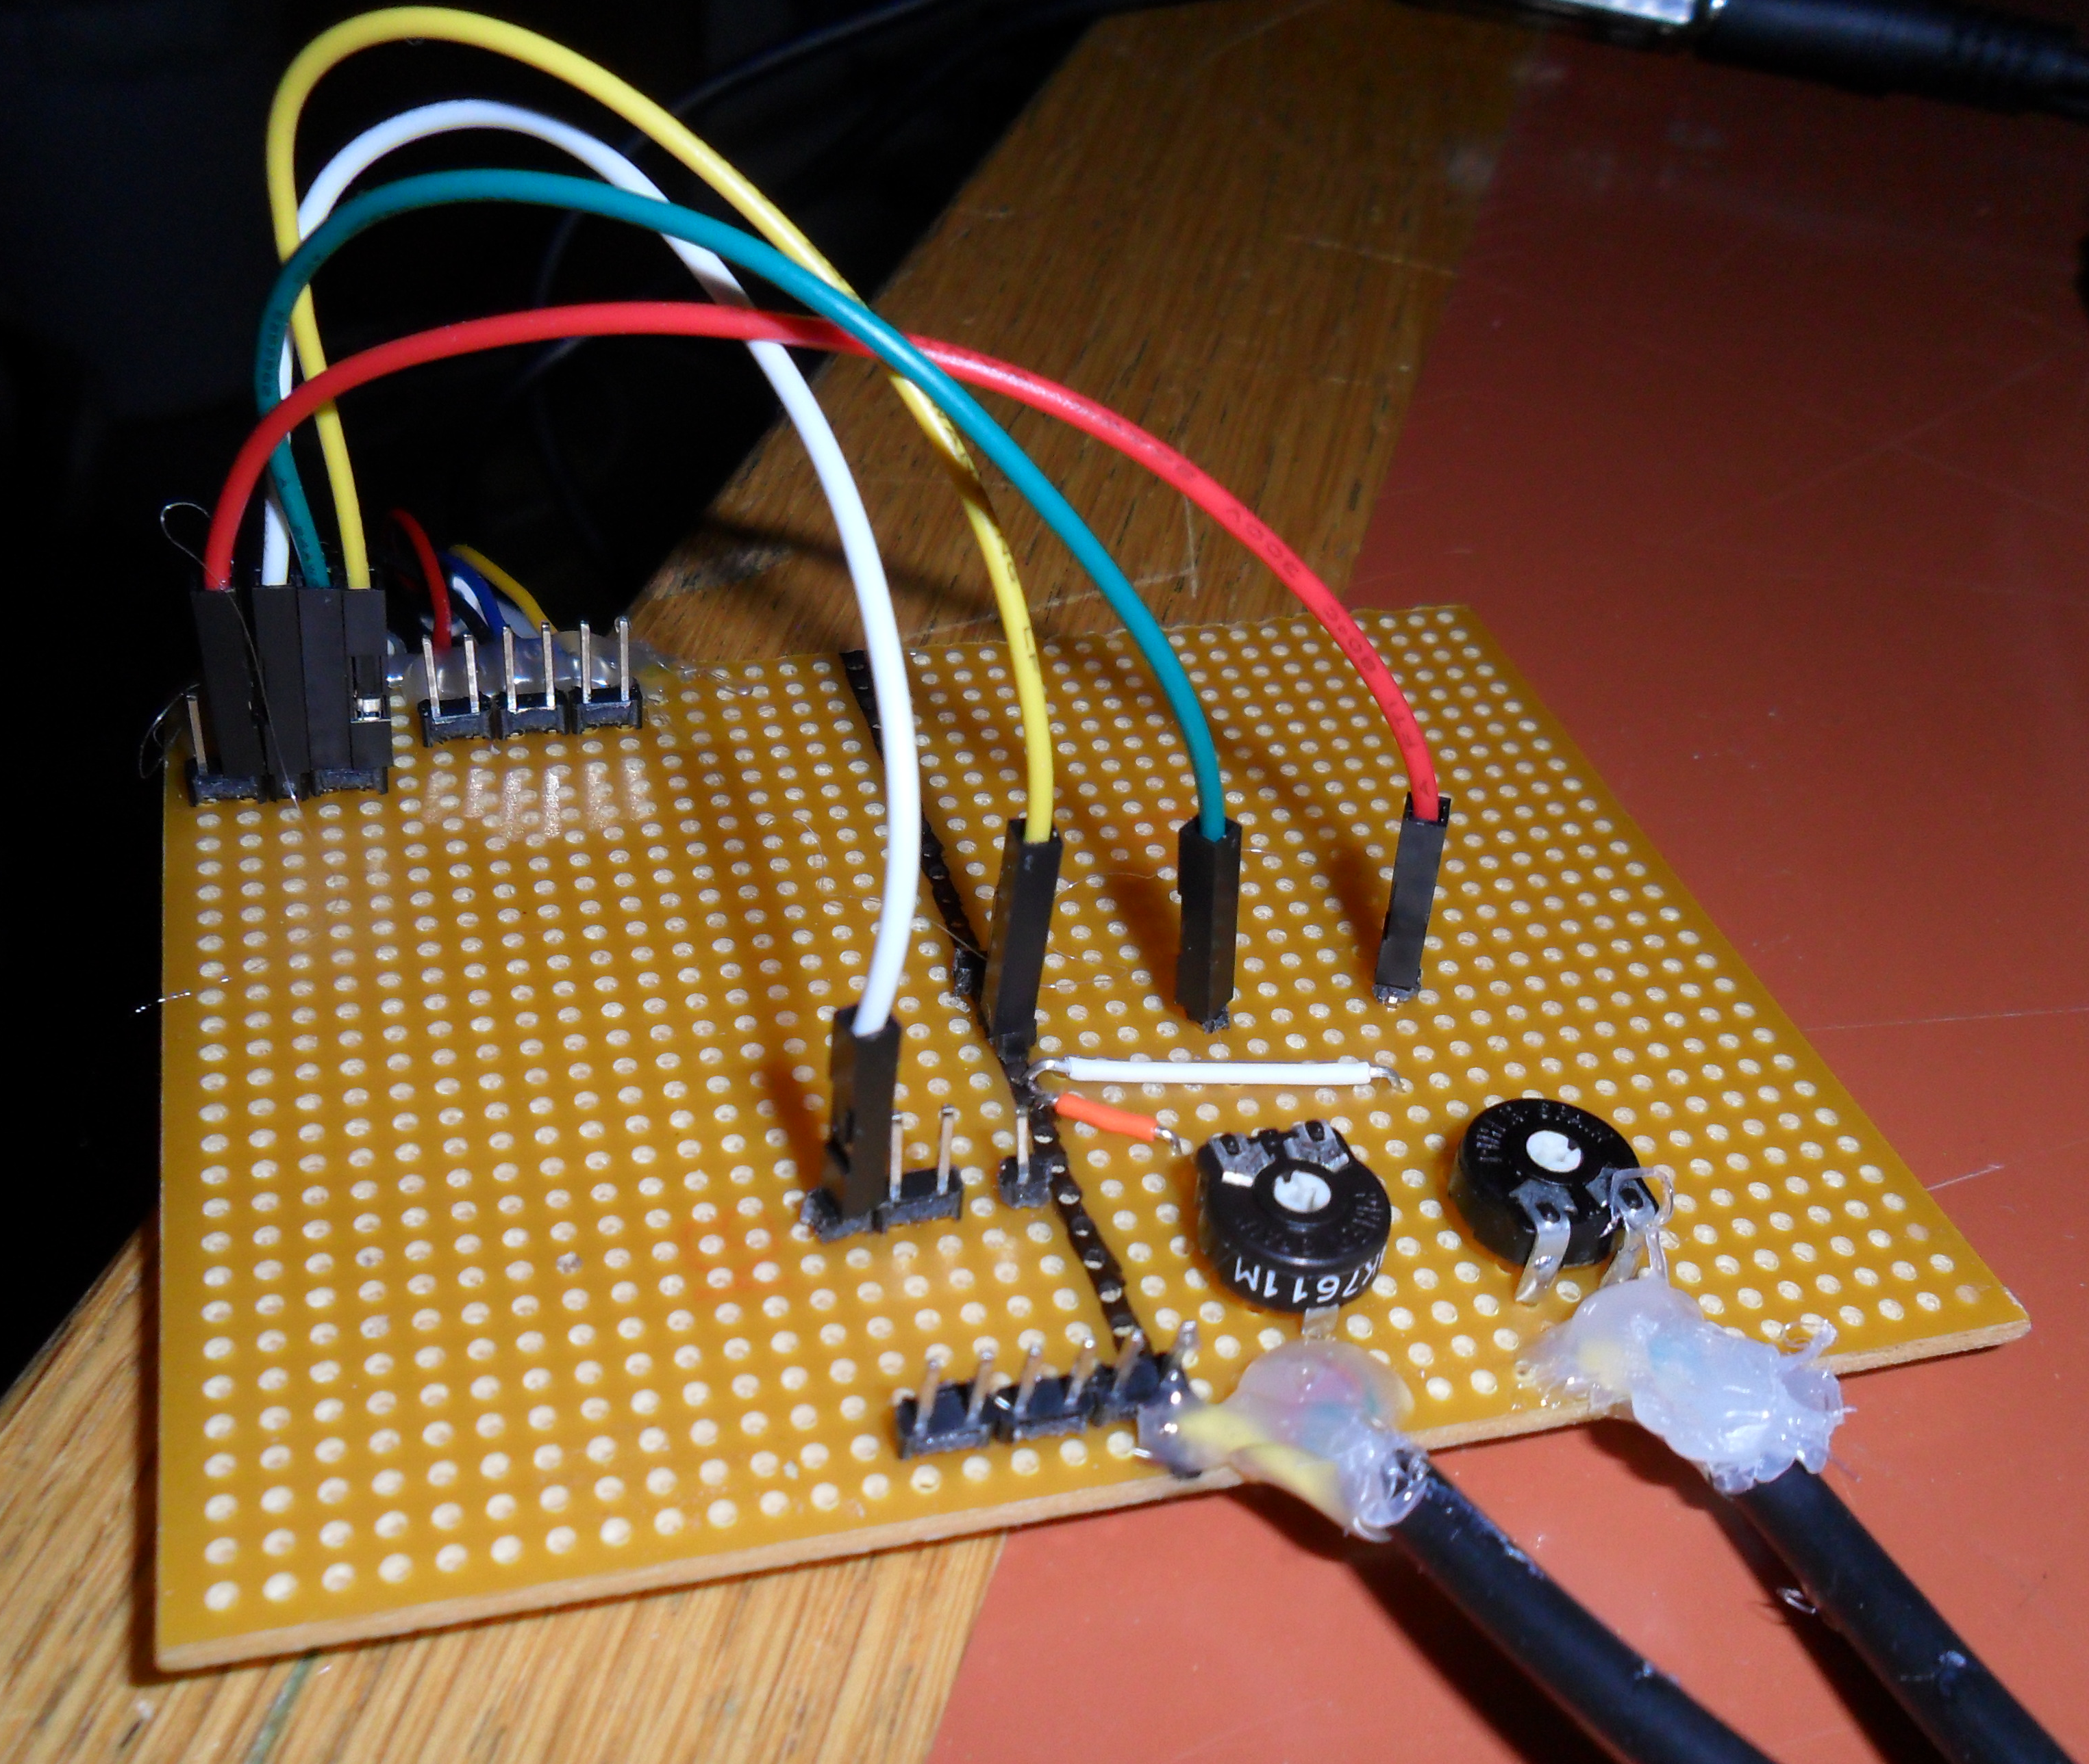

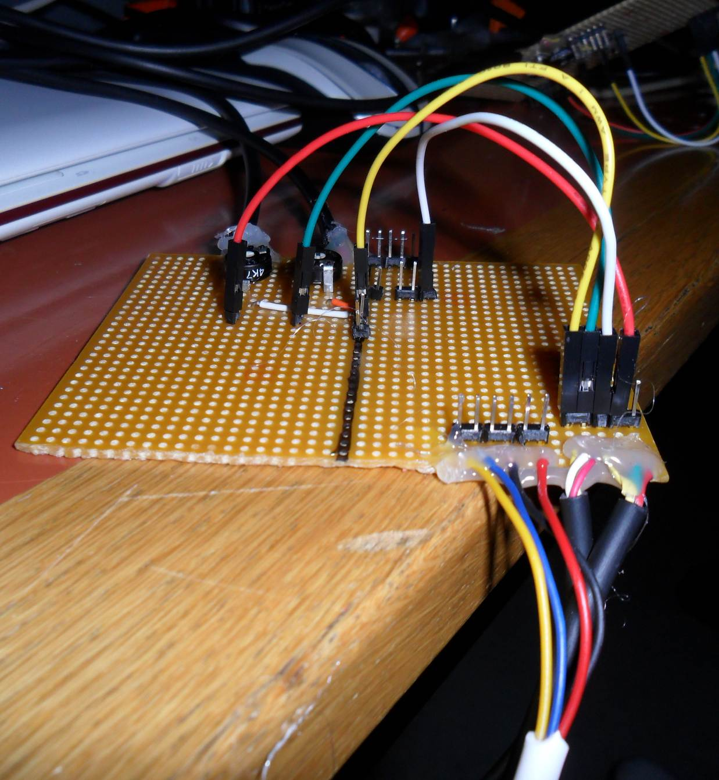
- If you are going to connect the YAESU radios, then the connections of the connectors on the radio side should be changed. One of the boards has 4 wires for radio connection (image above), and the other one has 6 wires (image below).
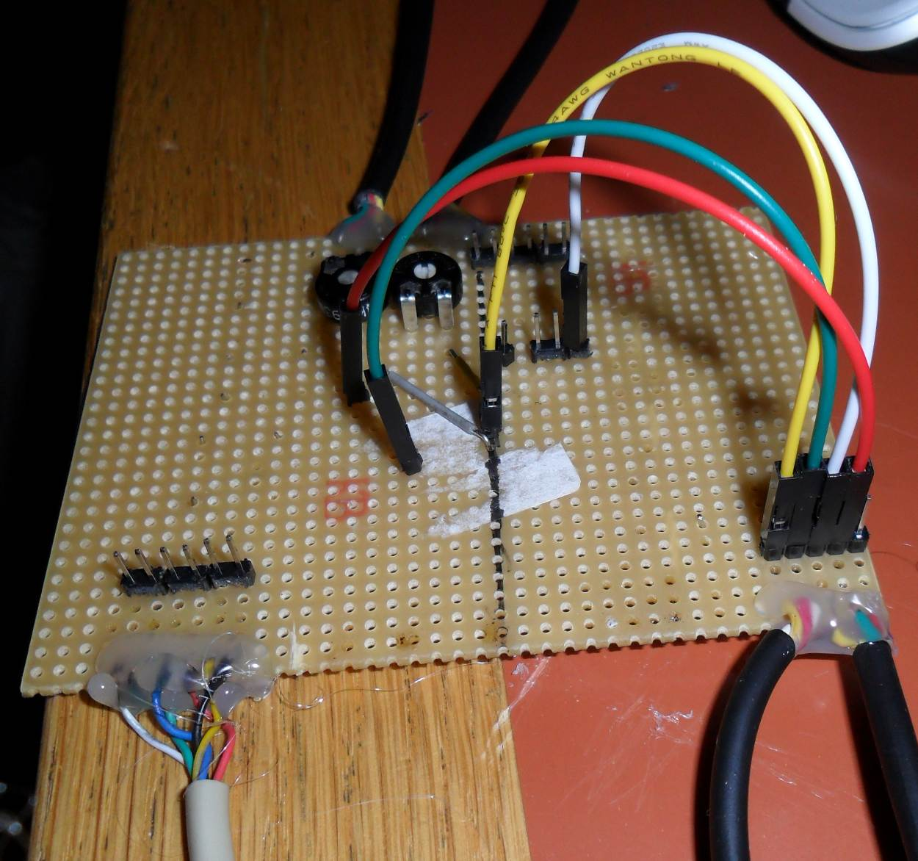

- For the board with 6 wires, colors of the cables, their functions and the end-points are in the image below and table below. Table is taken from YAESU FT8900R Operating Manual. Note that the colors in the operating manual do NOT match our cable’s colors.
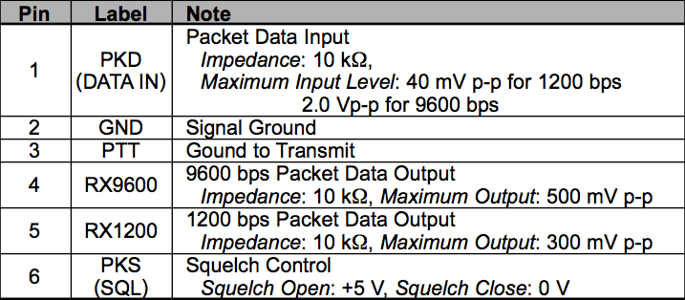
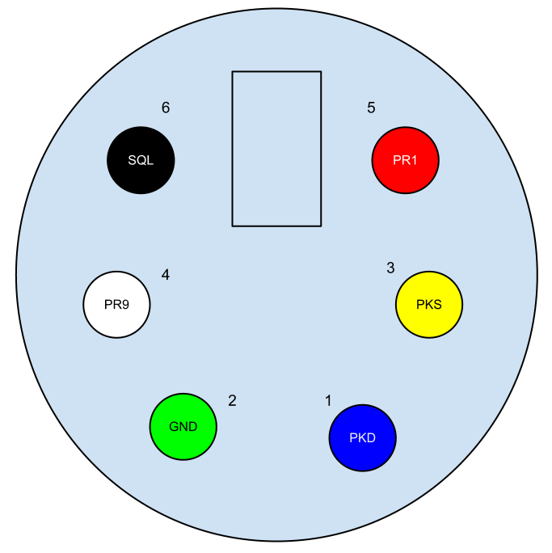
- For the other board (with 4 wires), the colors are the same except for black and yellow cable. In the board with 4 wires, the black cable stands for ground and the yellow stands for PTT.
- Repeat steps 27-31 for both radios.
- Now, you are ready for networking. In any case; be sure that both radios’ output volume setting is adjusted to a mean level. For handhelds, this was three stripes turn for me.
Next Steps are only for the remote client setup (the ALIX without internet connection):
- Plug in the sink mote via usb serial (FTDI cable). Check the device name from dmesg. Let’s say that is `/dev/ttyUSBY`.
- Start the `sensd` by typing in `sensd –fsensors.dat /dev/ttyUSBY`. When the data starts arriving, it should be saved into `sensors.dat` in the directory where you started `sensd`. Eg. If you started `sensd` from `/root` the data will be saved into `/root/sensors.dat` file.

